1. Create Table type based on MARA table

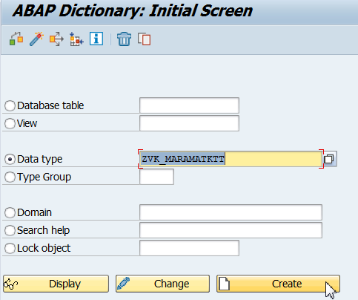

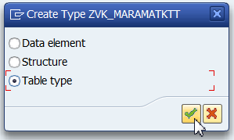

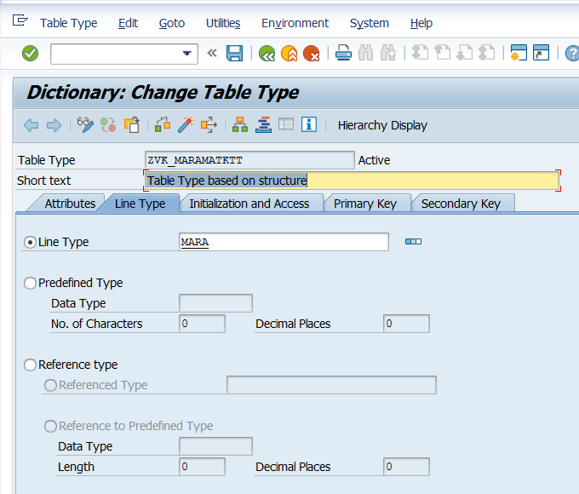

ZVK_MARAMATKTT

1. SE18

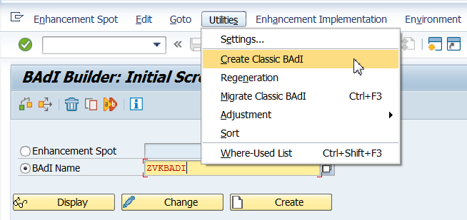

Save in package.

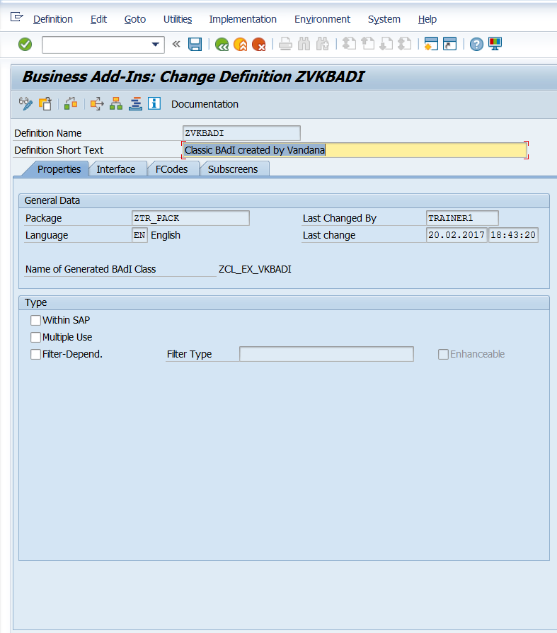

Double click on interface.

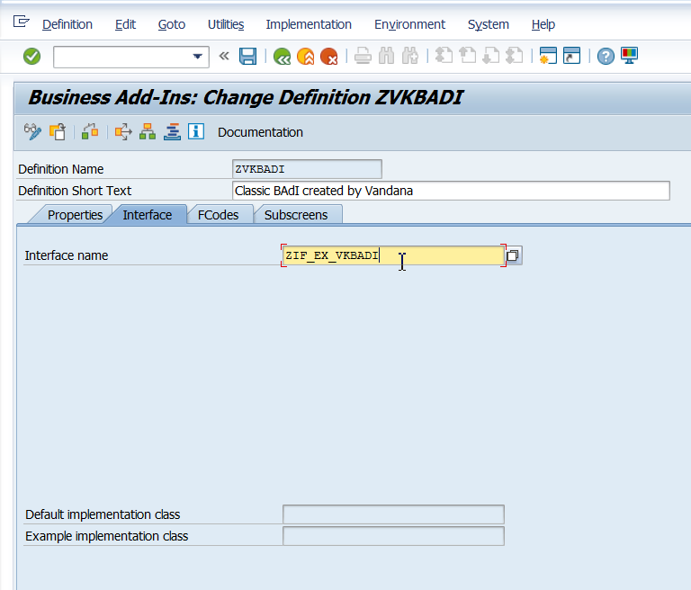

Double click on Interface. Give the method name as shown below.

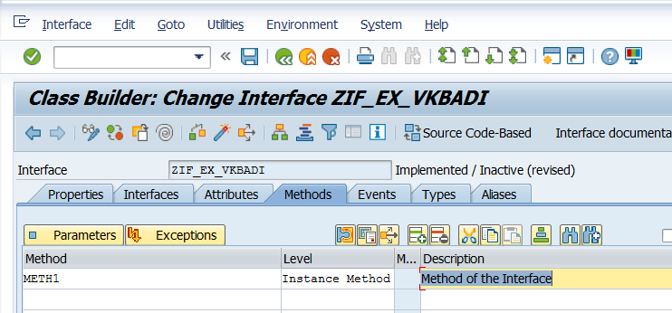

Click on parameters. Give parameters as shown below.

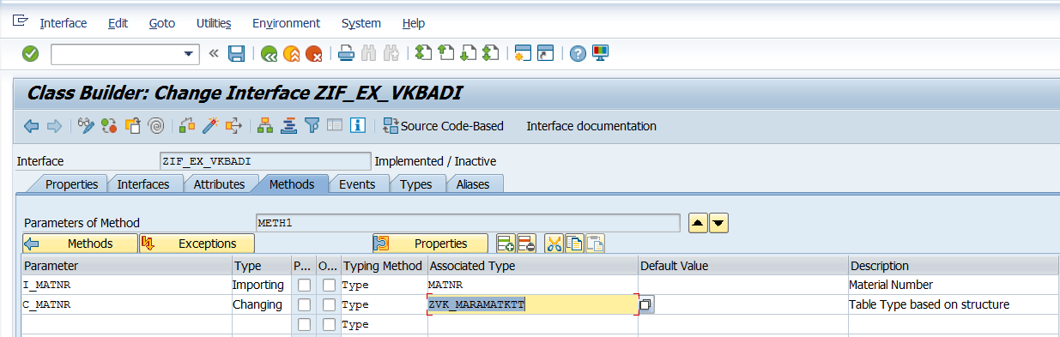

Save, Activate, Go Back.

1. SE19

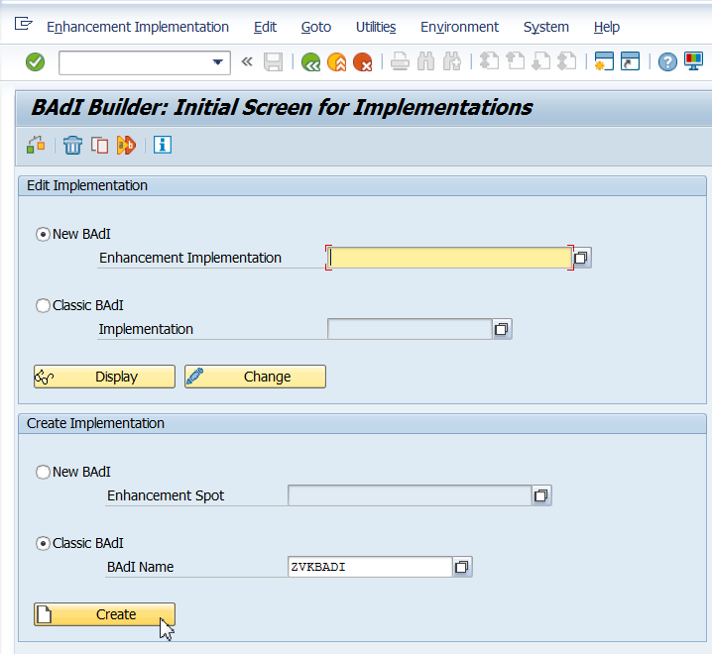

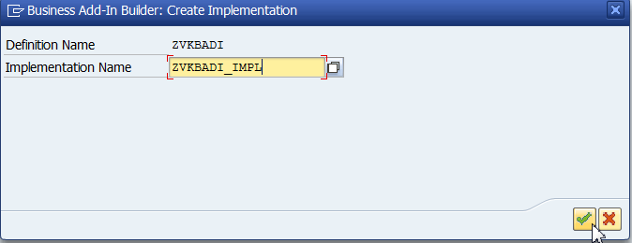

Double click on Method Name.

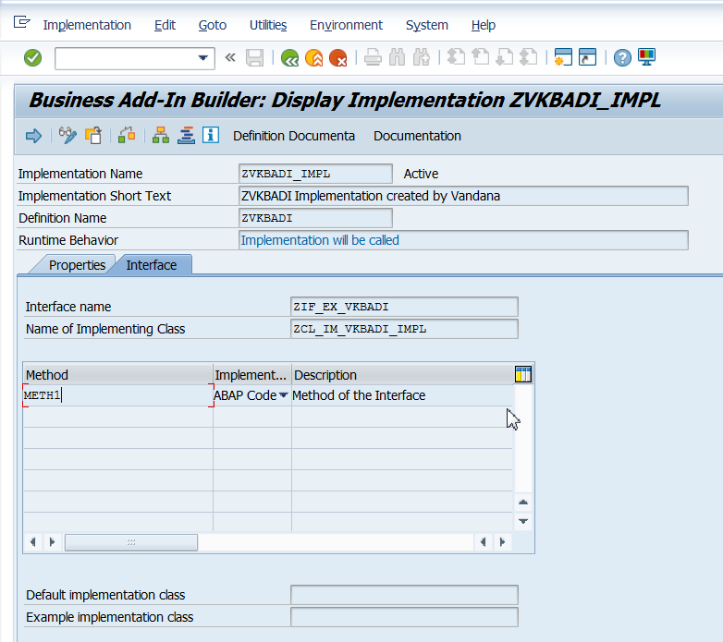

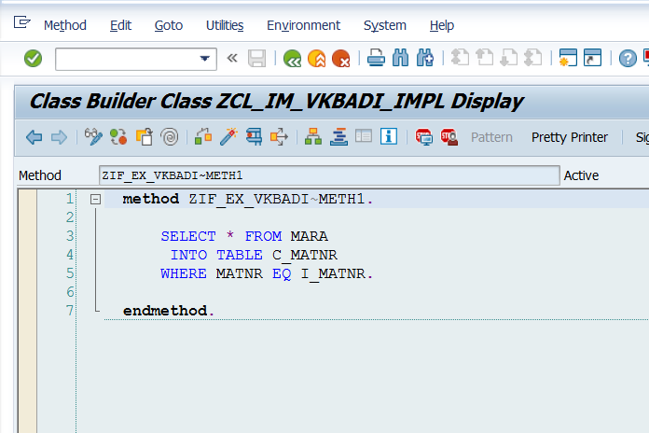

 SELECT * FROM MARA  
       INTO TABLE C_MATNR  
      WHERE MATNR EQ I_MATNR.

Save, Activate and execute SE38 program. Refer to notepad (Call Classic BADI) for SE38 program.